8.90: a For the 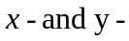directions, respectively, and as the common mass of a proton,

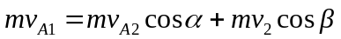
0 = 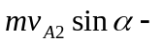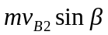

or

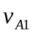 = 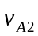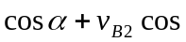
0 = 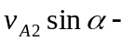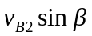.

bAfter minor algebra,

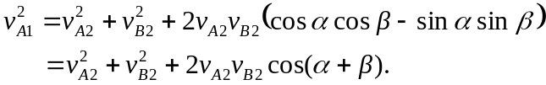

cFor a perfectly elastic collision,

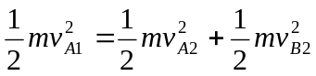 or 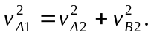

Substitution into the above result gives 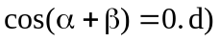 The only positive angle with zero cosine is 